Chapter 8, Solution 67.

At node 1,

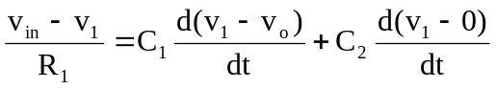 (1)

At node 2, 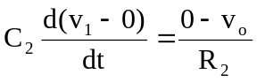, or 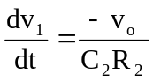 (2)

From (1) and (2),

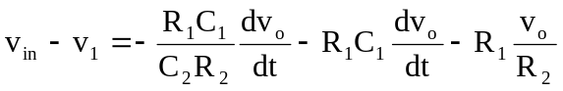

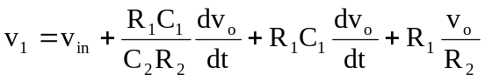 (3)
R₁
2
1
v₁
C₁
−
+
R₂
C₂
v_{in}
v_{o}
0V

From (2) and (3),

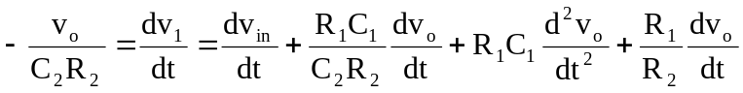

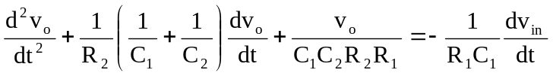

But C₁C₂R₁R₂ = 10⁻⁴ x10⁻⁴ x10⁴ x10⁴ = 1

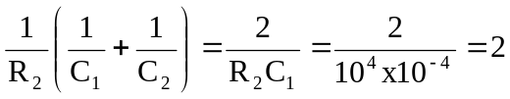

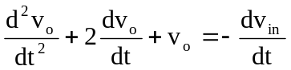

Which leads to s² + 2s + 1 = 0 or (s + 1)² = 0 and s = –1, –1

Therefore, v_{o}(t) = [(A + Bt)e^{-t}] + V_{f}

As t approaches infinity, the capacitor acts like an open circuit so that

V_{f} = v_{o}(∞) = 0

v_{in} = 10u(t) mV and the fact that the initial voltages across each capacitor is 0

means that v_{o}(0) = 0 which leads to A = 0.

v_{o}(t) = [Bte^{-t}]

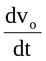 = [(B – Bt)e^{-t}] (4)
From (2), 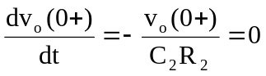

From (1) at t = 0+,

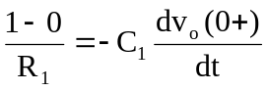 which leads to 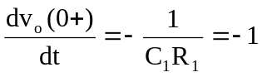

Substituting this into (4) gives B = –1

Thus, v(t) = –te^{-t}u(t) V

